TASK 2
ICT703: Programming
Bank Transaction Fraud Detection System
Student name: Adam Heier
Student ID: ____________
Campus: Online
Tutor's name: ____________
Due date: 18 September 2026
Submission date: 15 September 2026
Word count: 8922
Adam Heier
University of the Sunshine Coast

Table of Contents

Table of Figures

1 Introduction
Banks process very large numbers of transactions every day. Almost all of these transactions are normal, but a small number of them can show that a card or an account has been used by somebody who is not the real owner. Fraud analysts cannot read every single record by hand, so they need software that reads the transaction records automatically and points them to the small number of cases that are worth a closer look.
This report describes the Bank Transaction Fraud Detection System that I developed for ICT703 Assessment Task 2. The program is written in Python and reads fictional transaction records from a text file. It checks every record, keeps the valid records in memory, applies a set of fraud-detection rules to them and prints a clear list of the transactions and accounts that look suspicious. All data used in the program is fictional and was created for this assessment only.
The report explains the problem, the design of the program, the detection rules, the advanced features that I added, the testing that I carried out and the challenges that I met during development. The final section describes how I used artificial intelligence tools while working on the assessment.

2 Problem Description

2.1 Purpose of the program
The purpose of the program is to help a fraud analyst find suspicious activity in a file of bank transaction records. The program does not decide whether fraud really happened. It applies simple, clearly defined rules and produces a short list of transactions and accounts that a person should investigate. Every alert includes the reason why it was created, so the analyst can understand the decision without reading the program code.

2.2 Main functionality
The program provides the following functionality:
- It reads transaction records from a text file and handles a missing, empty or unreadable file without crashing.
- It validates every record and rejects records that do not meet the required format, with the line number and the reason for the rejection.
- It stores the valid records in a list and in a dictionary that is grouped by account ID.
- It applies nine fraud-detection rules: the three core rules from the task description and six additional rules that I added as advanced features.
- It prints every alert with the account ID, the related transaction IDs, the rule that was triggered and a short explanation.
- It prints a summary report and exports the valid records, the rejected records, the alerts and the summary to CSV files.

2.3 Transaction data used
The main data file transactions.txt contains 46 fictional records. The four example records from section 3.1 of the task description are included without any change, and the other records were written by me so that every rule and every validation check can be demonstrated. The fields are separated by the '|' character:
timestamp | transaction_id | account_id | transaction_type |
amount | location | status

2026-07-11 09:15:23 | T1001 | A10025 | TRANSFER | 850.00 |
Brisbane | APPROVED
Of the 46 records, 28 are valid and 18 are rejected by the validation. The file covers normal approved transactions, two approved transactions above $5,000, one account with four declined transactions, two accounts that were used in three different locations, one completely normal account that must not be flagged, and eighteen different kinds of invalid records.
The records are ordered by their timestamp and the invalid records are mixed in between the valid ones, because that is how a real file export would look. I did this on purpose rather than putting all the invalid records at the end: it shows that the program really continues with the next record after a rejection instead of stopping, and that the reported line numbers follow the file and not the order in which the records were checked. The one exception is the last record, which repeats the record from line 5. It stands at the end because a duplicate usually appears when the same data is added to a file a second time.
A second file, accounts.csv, contains nine fictional customer accounts with the account type, the home location, the daily limit and the account status. It is a real CSV file with a header row, so it is read with csv.DictReader. A third file, rules_config.json, contains the thresholds, the rule names and the severity levels. All three files are in the same folder as the program.

2.4 Assumptions
- Every record is written on one line and the fields are separated by '|'. Lines that start with '#' are comments and the first line that starts with 'timestamp' is a header line.
- All amounts are in Australian dollars, so the program does not deal with currencies or exchange rates.
- All timestamps are in the same time zone, so two timestamps can be compared directly.
- Records are processed in the order in which they appear in the file, and the transaction ID is unique for each transaction.
- The daily limit in the account file applies to the total of the approved transactions of one calendar day.

2.5 Known limitations
- The rules are threshold based. They show unusual behaviour, not proven fraud, so false alarms are possible. An account that is used during a holiday can trigger the multiple locations rule without any fraud.
- The whole file is loaded into memory. This is fine for a data file of this size, but it would not work for millions of records.
- The program does not have a graphical user interface and does not use a database. The results are printed to the console and written to CSV files.
- Rule 3 counts the locations over the complete file, as the task description allows. It does not check how much time passed between two locations, so it cannot tell a holiday from an impossible journey.
- The amount is stored as a float. For an assessment program this is accurate enough, but a real banking system would use the decimal module to avoid small rounding differences.

3 Program Design

3.1 Overall program structure
I built the program with classes, because each part of the problem has its own data and its own behaviour. To keep the project easy to follow, the solution is organised into three Python files that each have one clear job:
File | Purpose
main.py | The program itself. The class FraudDetectionApp runs the six steps of the analysis one after the other, and four print functions write the results to the console. This is the file that is started with python main.py.
fraud_detection.py | All the program logic, organised in eight numbered sections: helper functions, data model classes, rule configuration, validation, file loading, storage, the detection rules and the summary statistics. This file contains no console output at all, which is why the same classes can be used by main.py and by test.py.
test.py | The test program with 45 automatic test cases. It imports the classes from fraud_detection.py and does not need main.py, so the logic is tested without any screen output.

Only FraudDetectionApp is a class in main.py. The four functions that write to the console keep no data of their own: they receive what they have to print and return nothing. I first wrote them as methods of a ResultPrinter class, but that class had no attributes and never used self, so it only added a level without adding anything. FraudDetectionApp is a class because it does hold data between the steps, such as the configuration, the transaction store and the alerts.
The three files depend on each other in one direction only: main.py and test.py both import from fraud_detection.py, and fraud_detection.py does not import anything from the program itself. This separation of the logic from the output was a deliberate design decision, because it makes every class testable on its own.
Inside fraud_detection.py the classes are grouped in the order in which the program uses them:
Section | Classes | Purpose
1 | use_program_folder(),  write_csv(), make_alert(),  count_text(), amount_list() | Small helpers that are used in several places, so the same few lines are not written more than once.
2 | Transaction, Account,  InvalidRecord, Alert | The data model: one class for each kind of record.
3 | RuleConfig | Loads the thresholds, rule names and severity levels from the JSON file.
4 | TransactionValidator,  ValidationError | Checks one record and reports why it was rejected.
5 | TransactionLoader,  AccountLoader, DataFileError | Read the two data files and handle missing or empty files.
6 | TransactionStore,  AlertStore | Store the valid records and the alerts separately.
7 | FraudDetector,  AccountAnalyser | The nine fraud-detection rules.
8 | SummaryReport | Calculates the summary statistics.

3.2 Major classes and functions
Three kinds of file problem are handled in one place, in the function read_record_lines(). A missing file is found with os.path.exists(), a file that cannot be decoded as text raises a UnicodeDecodeError and a file without any usable record is treated as empty. All three raise the same DataFileError, so main.py only needs one except block to show a clear message instead of a Python error. Tests 2 to 4 check each of the three cases.
Class or function | What it does
use_program_folder() | Called first by main() and by the test program. It changes to the folder that holds the program, so that the relative file paths work no matter which folder the program was started from.
FraudDetectionApp.run() | Runs the whole analysis: load configuration, load transactions, load accounts, run the rules, show the results, export the CSV files.
TransactionValidator.validate() | Checks one record and returns a Transaction object, or raises a ValidationError with the field name and the reason.
TransactionLoader.load() | Reads the file line by line, sends every line to the validator and puts valid records into the store and invalid records into a separate list.
TransactionStore.add() | Adds a transaction to the list and to the dictionary that is grouped by account ID.
FraudDetector.detect_high_value() | Rule 1.
FraudDetector.detect_repeated_declines() | Rule 2.
FraudDetector.detect_multiple_locations() | Rule 3.
FraudDetector._first_group_in_window() | Helper that finds the first group of transactions inside a time window. It is used by rules 4 and 5, so the same loop is not written twice.
AccountAnalyser.run_all_checks() | Runs rules 6 to 9, which compare the transactions with the customer account file.
SummaryReport.build() | Calculates the summary statistics and returns them as a dictionary.

3.3 Data structures
Every valid record becomes a Transaction object. The objects are stored twice inside TransactionStore: once in a list, which keeps the original order of the file and is used by rule 1, and once in a dictionary where the key is the account ID and the value is a list of that account's transactions. The dictionary is used by all the rules that work on one account, because it avoids searching through the complete list again for every account.
The alerts are kept in a second class, AlertStore, so that the analysis never changes the original transaction data. Rejected records are kept in a third list of InvalidRecord objects.
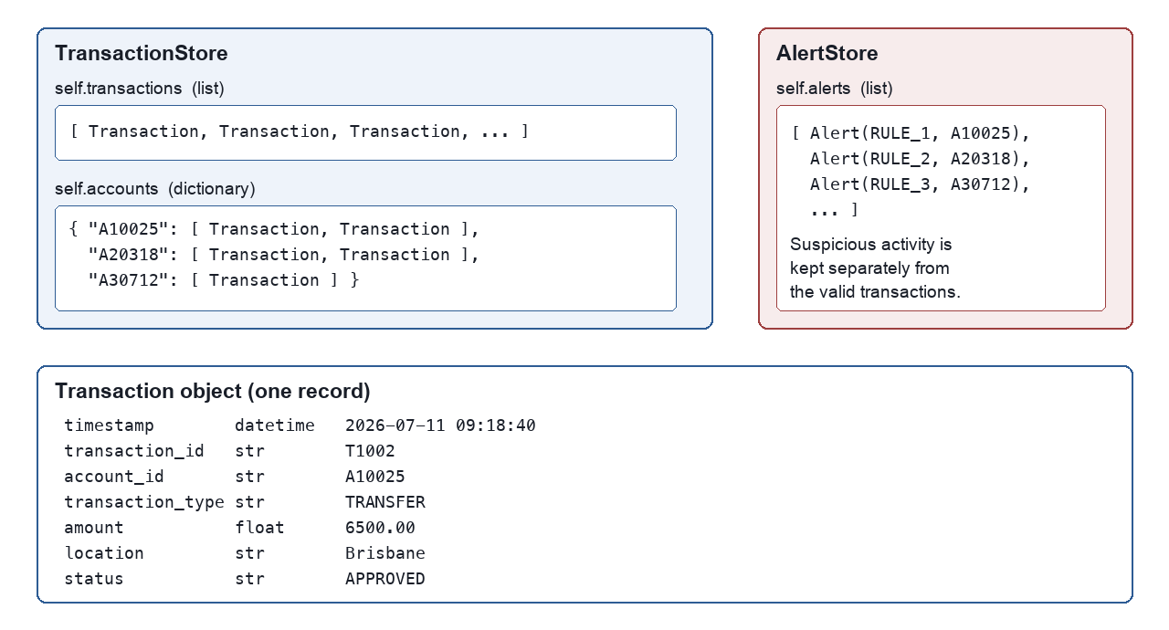
Figure : Data structures used to store transactions, accounts and alerts.

3.4 Pseudocode of the main program
LOAD the rule configuration from rules_config.json
IF the configuration file is missing THEN use the defaults

OPEN the transaction file
IF the file is missing or empty THEN
SHOW an error message and STOP

FOR every line in the transaction file
SKIP comment lines and the header line
VALIDATE the record
IF the record is valid THEN
STORE it in the transaction store
ELSE
STORE the line number and the reason in the
list of invalid records

LOAD the customer accounts from accounts.csv

FOR every transaction
IF status is APPROVED AND amount > 5000 THEN
CREATE an alert for rule 1

FOR every account
COUNT the declined transactions
IF the count >= 4 THEN CREATE an alert for rule 2
COUNT the different locations
IF the count >= 3 THEN CREATE an alert for rule 3
APPLY the time-based rules 4 and 5
COMPARE the account with the customer account file
(rules 6 to 9)

PRINT the invalid records, the alerts and the summary
EXPORT the results to CSV files

3.5 Techniques used from the course modules
The program is built from the techniques that were covered in the module topics and workshops, rather than from libraries that hide the work. The table shows where each one is used:
Module | Technique | Where it is used in the program
2 | Docstring header and  end-of-line comments | Every file starts with the Program / Author / Last date modified header from module 2, and the constants carry a short comment on the same line.
3 | Iteration, selection,  Boolean conditions | Every detection rule loops over the accounts and decides with an if statement; rule 1 combines two conditions with and.
4 | String methods and lists | split("|") and strip() cut a record into fields; the valid records are kept in a list.
5 | Reading a text file | read_record_lines() opens transactions.txt and loops over its lines.
6 | Dictionaries | TransactionStore groups the transactions by account ID, and the daily totals of rule 6 are a dictionary of dictionaries, like the inventory in the module 6 workshop.
6 | Sets | suspicious_account_ids() puts the flagged accounts in a set, so an account that triggers several rules is counted once.
6 | Tuples | read_record_lines() returns (line number, text) pairs, and load_main_file() in test.py returns two objects at once.
7 | Functions with default  and keyword arguments | TransactionValidator(enhanced=False) and the record() helper in test.py, where a test names only the field it changes.
7 | main() and the  entry point | main.py ends with if __name__ == "__main__": main().
8 | csv module | csv.DictReader reads accounts.csv by column name, and csv.writer writes the four result files.
8 | json module | json.load() reads the rule configuration.
8 | Testing vocabulary | test.py is grouped into black-box tests with positive and negative cases, equivalence partitioning for the rejection reasons and boundary value analysis on every threshold.
9 | Classes and objects | Twelve classes with __init__ and methods, for example Transaction, TransactionStore and FraudDetector.

Two modules were deliberately not used. Pandas (module 10) would make reading the files shorter, but it has to be installed first and the task asks for a program that runs after extraction without any changes. MySQL (module 11) needs a database server that a marker would have to set up, so the results are written to CSV files instead.

3.6 Program flow
Figure 2 shows the flow of the main program. The loop over the lines of the transaction file is the part that is repeated for every record; the detection rules run once, after all records have been read and stored.
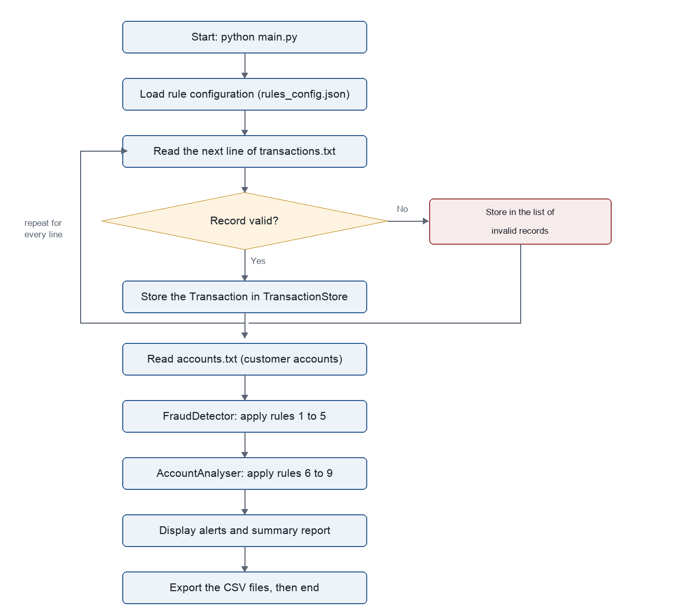
Figure : Flowchart of the main program.

4 Libraries and Dependencies
The program uses only modules from the Python Standard Library. No additional libraries have to be installed with pip, and the program runs on any computer with Python 3.8 or newer.
Library | Purpose in this program | Installation
datetime | datetime.strptime() converts the timestamp text into a datetime object, and timedelta is used for the time windows of rules 4 and 5. | Part of the Standard Library, no installation required.
json | json.load() reads the fraud-detection settings from rules_config.json (advanced feature 4). | Part of the Standard Library, no installation required.
csv | csv.writer() writes the exported result files in the output folder. | Part of the Standard Library, no installation required.
os | os.path.exists() and os.makedirs() check the data files and create the output folder. os.chdir() together with os.path.abspath(__file__) makes the relative file paths work from any folder. | Part of the Standard Library, no installation required.

The program is started with the command python main.py and the tests with python test.py. The data files are in the same folder as the program and are opened with relative paths such as transactions.txt, so the program runs after extraction without any changes. Before anything else, main() calls use_program_folder(), which changes to the folder that holds the program files. This means the relative paths also work when the program is started from a different folder or from an editor. The four CSV result files are written into a subfolder named output, which the program creates by itself.

5 Fraud Detection Rules
All detection rules are written as separate methods that return a list of Alert objects. None of the rules prints anything itself, which means that each rule can be tested on its own and that the output format can be changed in one place. The thresholds are not written into the code; every rule reads its threshold from the configuration object.

5.1 Rule 1 - High-value transactions
Rule 1 flags a single transaction that has the status APPROVED and an amount above the threshold of $5,000. The rule works on the list of all transactions, because it looks at one record at a time and does not need the account grouping.
def detect_high_value(self):
"""Rule 1: flag approved transactions above the limit."""
limit = self.config.threshold("high_value_amount")
alerts = []
for transaction in self.store.all_transactions():
if transaction.is_approved() and \
transaction.amount > limit:
alerts.append(self._create_alert(...))
return alerts
Both conditions are needed. A declined transaction of $9,000 was never paid out, so it is not flagged by this rule. The comparison uses the greater-than operator, which means that a transaction of exactly $5,000.00 is not flagged, which test 15 checks. In the sample data the rule creates two alerts:
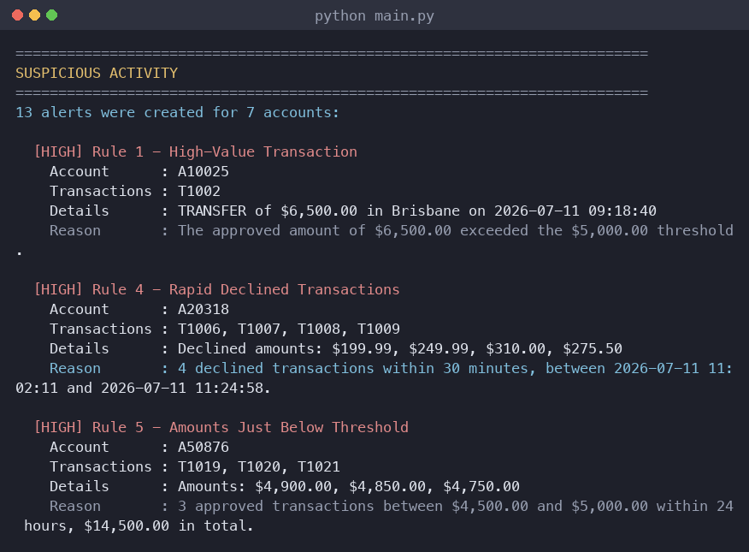
Figure : Console output of the detected suspicious activity. Every alert shows the account, the related transactions, the rule and the reason.

5.2 Rule 2 - Repeated declined transactions
Rule 2 works on accounts, not on single transactions. For every account ID in the store, the program collects the declined transactions and creates one alert if there are four or more of them. The alert lists every relevant transaction ID, so the analyst can find the records again in the data file.
for account_id in self.store.account_ids():
declined = self._declined_transactions(account_id)
if len(declined) >= limit:
alerts.append(self._create_alert(
"RULE_2", account_id,
transaction_ids(declined), reason, details))
One declined payment is completely normal, for example when a customer types a wrong PIN. Four declined payments on the same account are unusual and can mean that somebody is trying card details that do not belong to them. In the sample data, account A20318 has four declined online purchases and is flagged, while account A40199 has one declined payment and is not flagged.

5.3 Rule 3 - Multiple locations
Rule 3 counts how many different locations appear in the transactions of one account. I used a list and not a set for the locations, because a list keeps the order in which the locations appear and the output is easier to read for the analyst.
locations = []
for transaction in transactions:
if transaction.location not in locations:
locations.append(transaction.location)
if len(locations) >= limit:
...
In the sample data, account A30712 was used in Sydney, Melbourne and Perth on the same day and account A70455 was used in Darwin, Alice Springs and Katherine. Both accounts are flagged. Account A10025 was used in Brisbane and Sydney, which is only two locations, so it is not flagged by this rule.

5.4 How the advanced rules extend the core rules
The three core rules look at the complete file and only count transactions. The six additional rules extend them in two directions. Rules 4 and 5 add the time dimension: they use the timestamp field together with the status or the amount, so they can separate four declined payments within 23 minutes from four declined payments spread over a whole day. Rules 6 to 9 add information that is not part of a transaction record at all, because they compare each transaction with the customer account file. All nine rules use the same Alert class and the same AlertStore, so the output, the CSV export and the summary statistics work in exactly the same way for the core rules and for the advanced rules.

Rule | Description | Fields used | Alerts in sample data
1 | Approved amount above $5,000 | status, amount | 2
2 | Four or more declined transactions | status, account_id | 1
3 | Three or more different locations | location, account_id | 2
4 | Four or more declines within 30 minutes | status, timestamp, account_id | 1
5 | Three or more approved amounts between $4,500 and $5,000 within 24 hours | status, amount, timestamp | 1
6 | Approved daily total above the daily limit | status, amount, timestamp, account file | 1
7 | Transaction outside the home location | location, account file | 3
8 | Transaction on a suspended or dormant account | account_id, account file | 1
9 | Account ID not found in the account file | account_id, account file | 1

6 Advanced Features
I implemented six of the advanced features from section 5 of the task description. They are all part of the same program and are all covered by the test program.

6.1 Advanced feature 1 - Enhanced data validation
The validator has two modes. In core mode it performs only the checks of section 4.2 of the task description. In enhanced mode it also checks every field against the format rules of section 3.2 and performs five additional checks. The mode is switched on in the configuration file with the option enhanced_validation, and the program prints which mode is active when it starts.
Format checks in enhanced mode:
- timestamp must match YYYY-MM-DD HH:MM:SS, which is checked with datetime.strptime() inside a try/except block.
- transaction_id must be the letter T followed by four digits and account_id the letter A followed by five digits. Both follow the same pattern, so one method _check_id() checks them with len(), the first character and isdigit().
- amount must have at most two decimal places.
- location must not be empty.
Additional checks in enhanced mode:
- Duplicate transaction IDs. Accepted IDs are kept in a dictionary together with the line number, so the error message can name the line where the ID was used first.
- Duplicate complete records, using a second dictionary with the whole line as the key.
- Missing or additional fields, with a message that says how many fields were found.
- Inconsistent capitalisation, for example 'transfer' instead of 'TRANSFER'. The value is compared with value.upper() so that the message can suggest the correct spelling.
- Additional whitespace around a value. The file separates the fields with " | ", so after splitting on "|" a field may only look like value, " value", "value " or " value ". Anything else, a tab character included, is rejected.
Rejected records are stored separately as InvalidRecord objects and are exported to output/invalid_records.csv. The program always continues with the next record, so one bad line never stops the analysis. The invalid records are mixed in between the valid ones in the data file, which is how they would appear in a real export, and the rejected line numbers in the output range from line 6 to line 50. In the sample data, 18 of the 46 records are rejected:
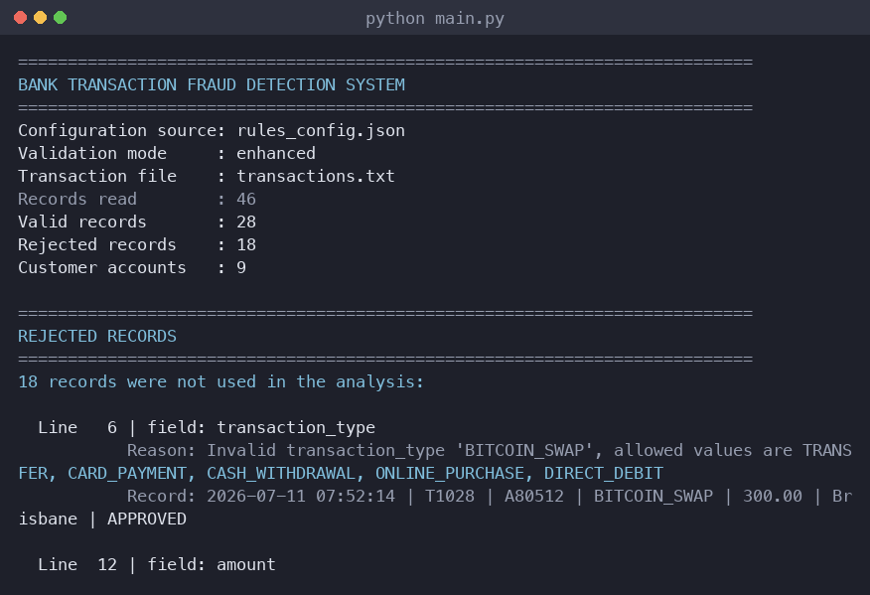
Figure : Console output when the program starts. Each rejected record is listed with its line number, the field that caused the problem and the reason.
Limitation: the whitespace check assumes that the file uses exactly one space around each '|' separator. A file that is formatted as a neat table with several spaces would be rejected even though the values themselves are correct.

6.2 Advanced feature 2 - Time-based fraud detection
I added two time-based rules. Rule 4 flags an account with four or more declined transactions inside a window of 30 minutes. Rule 5 flags an account with three or more approved transactions between $4,500 and $5,000 inside 24 hours, because splitting one large payment into several smaller payments is a known way of staying below a reporting threshold.
Both rules need the same kind of search: find a group of transactions that lie inside a time window. Instead of writing that loop twice, I wrote one helper method that both rules call:
def _first_group_in_window(self, transactions, window, limit):
ordered = sorted_by_time(transactions)
for start in range(len(ordered)):
group = [ordered[start]]
for later in ordered[start + 1:]:
if later.timestamp - ordered[start].timestamp \
<= window:
group.append(later)
if len(group) >= limit:
return group
return []
The subtraction of two datetime objects returns a timedelta, which can be compared directly with the window. Both rules use at least two fields and both were tested with suspicious data and with normal data. Tests 29 and 30 use the same four declined transactions; in the first test they happen between 11:02 and 11:24 and an alert is created, in the second test they are spread from 09:00 to 15:00 and no alert is created.
Limitation: the helper compares every transaction with the first one of the group and stops at the first group it finds, so an account receives at most one alert per rule even if there are several separate bursts.

6.3 Advanced feature 3 - Advanced storage and management
Suspicious activity is stored separately from the valid transactions. The class AlertStore keeps the alerts and provides methods to search and filter them: filter_by_rule(), filter_by_account(), count_for_rule(), suspicious_account_ids(), suspicious_transaction_ids() and sorted_by_severity(). TransactionStore provides find_by_id(), filter_by_type(), filter_by_status() and sorted_by_amount().
The method suspicious_account_ids() is also the answer to a requirement of advanced feature 7: an account that triggers several rules is added to the list only once, because the method checks whether the ID is already in the list before it appends it. In the sample data, account A50876 triggers rule 5 and rule 6, but is counted as one suspicious account.
Both stores can export their content to CSV. The program writes four files into a subfolder named output: valid_transactions.csv, invalid_records.csv, alerts.csv and summary_report.csv. All four exports use the same helper function write_csv(), which also creates the output folder the first time the program runs, so the code for writing a CSV file only exists once.

6.4 Advanced feature 4 - Configurable fraud rules
All thresholds, rule names and severity levels are stored in rules_config.json and are loaded when the program starts:
{
"thresholds": {
"high_value_amount": 5000.00,
"declined_count": 4,
"location_count": 3,
"rapid_decline_count": 4,
"rapid_decline_window_minutes": 30,
...
},
"rule_names": {
"RULE_1": "Rule 1 - High-Value Transaction", ...
},
"severities": {
"RULE_1": "HIGH", "RULE_2": "MEDIUM", ...
},
"options": {"enhanced_validation": true}
}
The file has four flat sections, which keeps both the file and the code that reads it simple: one lookup per section, for example self.settings["rule_names"][rule_key]. The class RuleConfig first fills itself with built-in default settings and then updates each section with the values from the file. This has two advantages: a configuration file that only contains one threshold still works, and a missing or damaged file does not stop the program. In that case the defaults are used and a warning is printed. Tests 36 to 38 check this behaviour, including a test that runs rule 1 twice on the same transaction of $2,500 - with the standard threshold no alert is created, and with a threshold of $1,000 one alert is created.

6.5 Advanced feature 5 - Customer account analysis
The second data file accounts.csv contains the columns account_id, account_type, home_location, daily_limit and account_status. It is a real CSV file, so it is read with csv.DictReader from the csv module rather than by splitting the line by hand. Every row then arrives as a dictionary and a field can be read by its column name:
with open(file_path, "r", newline="",
encoding="utf-8") as account_file:
rows = list(csv.DictReader(account_file))

# a field is now read by its name, not by a column number
daily_limit = float(row["daily_limit"])
The class AccountAnalyser compares the transactions with this information and adds four rules:
- Rule 6 adds up the approved amounts of each calendar day and compares the total with the daily limit of the account. In the sample data, account A50876 spent $14,500.00 on 2026-07-12 with a limit of $10,000.00.
- Rule 7 flags transactions that were made outside the home location of the account.
- Rule 8 flags any transaction on an account whose status is not ACTIVE. Account A60234 is SUSPENDED but has two cash withdrawals.
- Rule 9 flags a transaction whose account ID does not appear in the account file at all, such as A90123.
If the account file is missing, the program prints a warning, skips rules 6 to 9 and continues with the core rules, so the advanced feature never breaks the core program.

6.6 Advanced feature 7 - Summary statistics and reporting
The class SummaryReport collects all the statistics that are listed in the task description and prints them at the end of the analysis. The statistics are stored in a dictionary, which is used for the console output and for the CSV export, so the two outputs can never disagree.
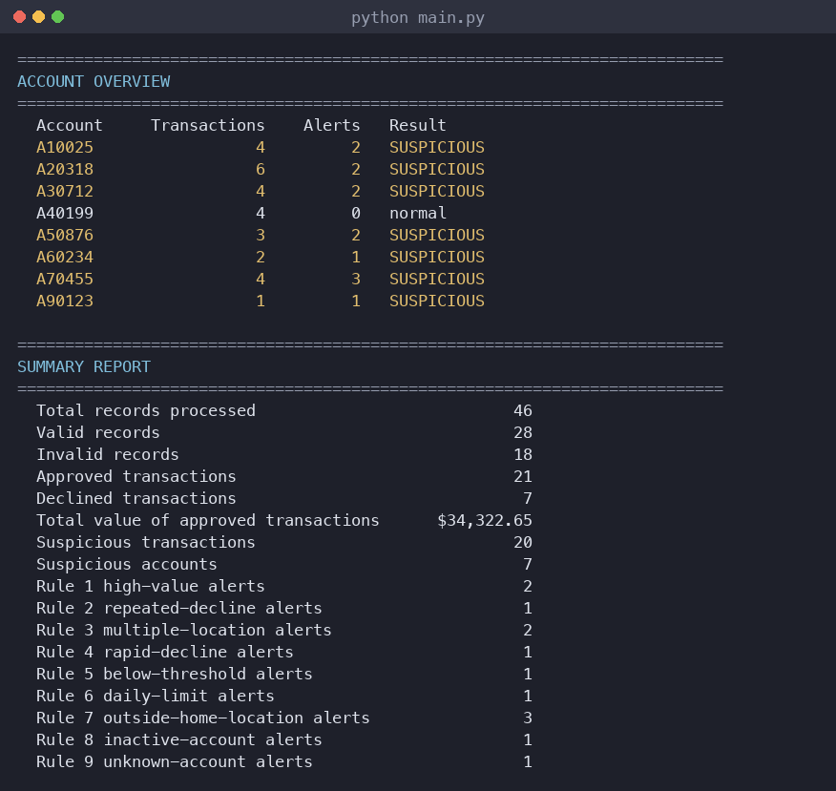
Figure : Console output of the account overview and the summary report. Account A40199 is the control account and is correctly listed as normal.
The summary is exported to output/summary_report.csv. I chose CSV because it can be opened in Excel and does not need an additional library, which keeps the program dependency free.

7 Testing

7.1 Test plan
The test program test.py runs 45 automatic test cases and does not ask for any user input. It is started with python test.py from the program folder. All test data is written inside test.py, so no extra test files are needed. I wrote a small class TestRunner that compares an expected value with an actual value, prints the feature, the input, the expected result, the actual result and the outcome, and counts how many tests passed and failed.
def check(self, feature, test_input, expected, actual):
"""Compare the expected and the actual result."""
self.number += 1
if expected == actual:
outcome = "PASS"
self.passed += 1
else:
outcome = "FAIL"
self.failed += 1
The tests follow the vocabulary from module 8. They are black-box tests: each one calls a function with an input and compares the result with the expected value, without looking at the steps inside. Every group contains positive cases (input that should be accepted or should trigger a rule) and negative cases (input that should be rejected or should trigger nothing). For the validation I used equivalence partitioning: each rejection reason is one class of invalid input, so one record per class is enough, and each of those records differs from a valid record in exactly one field. For the rules I added boundary value analysis, because a threshold is where a wrong comparison operator hides.
The test plan follows the structure of the program. Each group of tests covers one part, and the groups are run one after the other:

Tests | Group | What is tested
1 - 4 | File handling | Reading the main data file, a missing file, an empty file and a file that is not valid text. The last two are created by the test itself.
5 - 13 | Core data validation | A valid record and the seven rejection reasons required by section 4.2.
14 - 20 | Core fraud-detection rules | Rules 1 to 3 with suspicious data, with boundary values and with a normal account.
21 - 28 | AF 1 - Enhanced validation | Core mode against enhanced mode, the field format checks, duplicate IDs, and one test that runs every check at once against the data file.
29 - 32 | AF 2 - Time-based rules | Rules 4 and 5 with transactions inside and outside the time window.
33 - 35 | AF 3 - Storage and management | Search and sort methods, and that an account is only counted once.
36 - 38 | AF 4 - Configurable rules | Missing configuration file, and the same transaction with two different thresholds.
39 - 42 | AF 5 - Customer accounts | Rules 6 to 9, each against the real accounts.csv file.
43 - 45 | AF 7 - Summary statistics | The calculated totals and the CSV export.

I kept the number of test cases deliberately small. Every test that section 6.2 of the task description asks for is included, every fraud-detection rule is tested with data that should trigger it and with data that should not, and each advanced feature has its own group of tests. Instead of writing one test for each of the eleven validation checks, test 28 runs the complete data file through the validator: the file contains one record for every rejection reason, so a single test covers all of them and also checks that the export file has the same number of rows.
The tests use three kinds of input: valid and invalid records, normal and suspicious transactions, and boundary values. The boundary tests were the most useful ones, because they check the exact comparison operator of each rule: an approved amount of exactly $5,000.00 (test 15), three declined transactions instead of four (test 17) and two locations instead of three (test 19). Test 20 runs all core rules on a completely normal account and expects zero alerts, which makes sure that the program does not flag ordinary customers.
Writing out a full record for every test would have made the file long and hard to read, so all test records are built by one helper function. Every field has a valid default value, which means a test only has to name the one field it is testing:
def record(tid="T3001", account="A10025", kind="TRANSFER",
amount="850.00", place="Brisbane",
status="APPROVED", time="2026-07-11 09:15:23"):
"""Build one transaction record line."""
return (f"{time} | {tid} | {account} | {kind} | "
f"{amount} | {place} | {status}")
A test case is then a single, readable line. record() is a normal valid record, record(amount="abc") is the same record with a non-numeric amount, and record(kind="transfer") is the same record with the wrong capitalisation. Because only one field differs from a valid record, a failing test can only fail for the reason it is testing.
Most rule tests then build a small transaction store from a list of those record lines:
def build_store(lines, enhanced=False):
"""Create a transaction store from a list of lines."""
validator = TransactionValidator(enhanced)
store = TransactionStore()
for line_number, line in enumerate(lines, start=1):
store.add(validator.validate(line, line_number))
return store

7.2 Test cases and results
The following table lists all 45 test cases with their input, the expected result, the actual result and the outcome. The values are taken from the output of test.py. Long record inputs are shown with the field that was changed, because the rest of the record is a normal valid record.

# | Feature or function tested | Test input | Expected | Actual | Result
1 | TransactionLoader.load - valid file | transactions.txt | 46 read, 28 valid | 46 read, 28 valid | PASS
2 | TransactionLoader.load - missing file | this_file_does_not_exist.txt | DataFileError | DataFileError | PASS
3 | TransactionLoader.load - empty file | output/temp_empty.txt | DataFileError | DataFileError | PASS
4 | TransactionLoader.load - unreadable file | output/temp_broken.txt | DataFileError | DataFileError | PASS
5 | TransactionValidator.validate - valid record | valid record T3001 | accepted | accepted | PASS
6 | TransactionValidator.validate - incorrect number of fields | record with 6 fields | rejected (record) | rejected (record) | PASS
7 | TransactionValidator.validate - invalid transaction type | T3001: transaction_type = BITCOIN_SWAP | rejected (transaction_type) | rejected (transaction_type) | PASS
8 | TransactionValidator.validate - invalid status value | T3001: status = REJECTED | rejected (status) | rejected (status) | PASS
9 | TransactionValidator.validate - non-numeric amount | T3001: amount = abc | rejected (amount) | rejected (amount) | PASS
10 | TransactionValidator.validate - zero amount | T3001: amount = 0.00 | rejected (amount) | rejected (amount) | PASS
11 | TransactionValidator.validate - negative amount | T3001: amount = -50.00 | rejected (amount) | rejected (amount) | PASS
12 | TransactionValidator.validate - empty transaction ID | record: transaction_id = (empty) | rejected (transaction_id) | rejected (transaction_id) | PASS
13 | TransactionValidator.validate - empty account ID | T3001: account_id = (empty) | rejected (account_id) | rejected (account_id) | PASS
14 | Rule 1 - approved transaction above $5,000 | T4002 approved, $6,500.00 | 1 alert for T4002 | 1 alert for T4002 | PASS
15 | Rule 1 - boundary value of exactly $5,000 | T4003 approved, $5,000.00 | 0 | 0 | PASS
16 | Rule 2 - four declined transactions on one account | 4 declined transactions for A20318 | 1 | 1 | PASS
17 | Rule 2 - boundary value of three declined transactions | 3 declined transactions for A20318 | 0 | 0 | PASS
18 | Rule 3 - transactions in three different locations | Sydney, Melbourne, Perth | 1 | 1 | PASS
19 | Rule 3 - boundary value of two different locations | Sydney, Melbourne | 0 | 0 | PASS
20 | All rules - normal account must not be flagged | A40199 with 3 small transactions in one location | 0 | 0 | PASS
21 | Enhanced validation - transaction ID format (core mode) | transaction_id = TX999 | accepted | accepted | PASS
22 | Enhanced validation - transaction ID format | transaction_id = TX999 | rejected (transaction_id) | rejected (transaction_id) | PASS
23 | Enhanced validation - account ID format | T5001: account_id = A8051 | rejected (account_id) | rejected (account_id) | PASS
24 | Enhanced validation - timestamp format | T5002: timestamp = 11/07/2026 09:15:23 | rejected (timestamp) | rejected (timestamp) | PASS
25 | Enhanced validation - inconsistent capitalisation | T5003: transaction_type = transfer | rejected (transaction_type) | rejected (transaction_type) | PASS
26 | Enhanced validation - additional whitespace | T5004: extra whitespace | rejected (record) | rejected (record) | PASS
27 | Enhanced validation - duplicate transaction ID | T3001 used twice | Duplicate transaction ID 'T3001', already used on line 1 | Duplicate transaction ID 'T3001', already used on line 1 | PASS
28 | Enhanced validation - all checks on the data file | transactions.txt | 18 rejected, 18 exported | 18 rejected, 18 exported | PASS
29 | Rule 4 - four declined transactions within 30 minutes | 4 declined transactions between 11:02 and 11:24 | 1 | 1 | PASS
30 | Rule 4 - four declined transactions over six hours | 4 declined transactions between 09:00 and 15:00 | 0 | 0 | PASS
31 | Rule 5 - three approved amounts just below $5,000 | $4,900.00, $4,850.00, $4,750.00 within one hour | 1 | 1 | PASS
32 | Rule 5 - only two amounts just below $5,000 | $4,900.00, $4,850.00 | 0 | 0 | PASS
33 | TransactionStore.find_by_id | T2002 | 6500.0 | 6500.0 | PASS
34 | TransactionStore.sorted_by_amount | highest first | T2002 | T2002 | PASS
35 | AlertStore.suspicious_account_ids - counted once | 5 sample records | ['A10025'] | ['A10025'] | PASS
36 | RuleConfig - missing file uses the default settings | no_such_config.json | built-in default settings | built-in default settings | PASS
37 | Rule 1 - $2,500.00 with the standard threshold | threshold $5,000.00 | 0 | 0 | PASS
38 | Rule 1 - $2,500.00 with the lowered threshold | threshold $1,000.00 | 1 | 1 | PASS
39 | Rule 6 - approved total above the daily limit | A40199 spent $2,400.00, limit $2,000.00 | 1 | 1 | PASS
40 | Rule 7 - transaction outside the home location | A40199 used in Perth, home location Hobart | 1 | 1 | PASS
41 | Rule 8 - transaction on a suspended account | A60234 has the status SUSPENDED | 1 | 1 | PASS
42 | Rule 9 - account is not in the customer account file | A99999 | 1 | 1 | PASS
43 | SummaryReport - total value of approved transactions | transactions.txt | $34,322.65 | $34,322.65 | PASS
44 | SummaryReport - suspicious accounts counted once | transactions.txt | 7 | 7 | PASS
45 | SummaryReport.export_to_csv | output/temp_summary.csv | True | True | PASS

All 45 tests passed. The output of the test program shows the feature, the input, the expected result, the actual result and the outcome of every test:
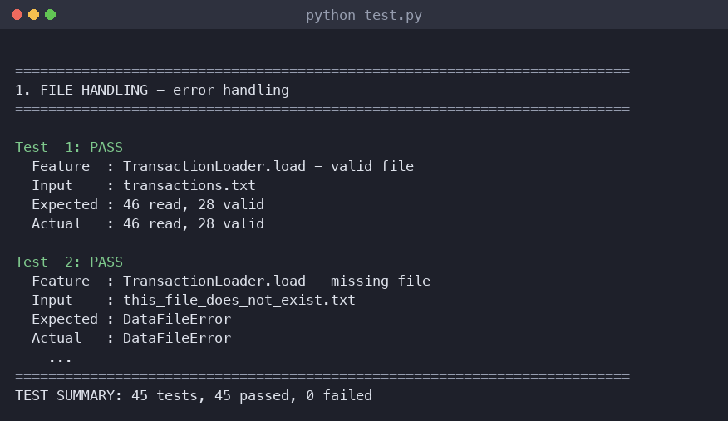
Figure : Console output of the test program.

7.3 Testing the complete program
In addition to the automatic tests I ran main.py on the full sample data and checked the output by hand against the data file. The program reads 46 records, accepts 28 and rejects 18, and creates 13 alerts for 7 accounts. Account A40199 has four transactions, one of them declined, all in Hobart, and it is correctly listed as normal in the account overview:
Account Transactions Alerts Result
A10025 4 2 SUSPICIOUS
A20318 6 2 SUSPICIOUS
A30712 4 2 SUSPICIOUS
A40199 4 0 normal
A50876 3 2 SUSPICIOUS
A60234 2 1 SUSPICIOUS
A70455 4 3 SUSPICIOUS
A90123 1 1 SUSPICIOUS
I also checked the style of the code with the tool pycodestyle, which reports differences from PEP 8. The command python -m pycodestyle --max-line-length=79 *.py reports no problems for any of the three Python files.

8 Challenges and Future Improvements

8.1 Challenges during development
Deciding how to store the data was the first challenge. My first idea was to use only a list of dictionaries, which is the simplest structure. It worked for rule 1, but rules 2 and 3 needed all transactions of one account, and searching the whole list again for every account felt wrong. I changed the design so that TransactionStore keeps the records in a list and in a dictionary that is grouped by account ID at the same time. The list keeps the order of the file and the dictionary makes the account rules short and fast. I also changed from plain dictionaries to a Transaction class, because transaction.amount is easier to read than record["amount"] and a typing mistake in an attribute name is noticed immediately.
The second challenge was a bug in my whitespace check. My first version searched the complete line for two spaces next to each other. That looked correct, but when I ran the program, three records were rejected with the message 'Record contains additional whitespace' although the real problem was an empty field. An empty field between two separators produces two spaces, so my check found its own false positive. I rewrote the check so that it looks at each field separately, skips empty fields and counts the spaces at the start and at the end of a field. After the change, the three records were rejected with the correct messages 'Transaction ID is empty', 'Account ID is empty' and 'Location is empty'.
The third challenge was the time window of rules 4 and 5. I first compared only transactions that follow each other directly, but that does not answer the question 'were there four declines within 30 minutes'. I then wrote the helper _first_group_in_window(), which starts at every transaction and counts how many later transactions lie inside the window. Writing it as one helper for both rules also removed duplicated code.
The fourth problem only appeared when I tested the finished program the way a marker would use it. I had extracted the ZIP file and started the program from the folder above it, and it stopped with the message 'The file transactions.txt was not found'. The error handling itself worked exactly as intended, but the cause was my own use of relative paths: a relative path is resolved from the folder the program was started in, not from the folder the program is stored in. I added the function use_program_folder(), which uses os.path.abspath(__file__) to find the folder of the program file and os.chdir() to change into it. It is called as the first line of main() and of the test program. I then tested the program from three different folders and it produced the same result every time. This keeps the short, readable relative paths that the task description asks for and still makes the program run without modification after extraction.
A smaller problem was the wording of the output. An early version printed 'The account was used for 1 transactions', which looks careless. I added a small function count_text() that returns the singular or the plural form, and used it everywhere a number is printed with a word.

8.2 Future improvements
- Give the analyst an interactive menu so that alerts can be searched by account ID, by rule or by severity without changing the code. The filter methods in AlertStore already exist, so only the menu would have to be added.
- Store the alerts in an SQLite database instead of a CSV file, together with an investigation status such as OPEN, IN PROGRESS or CLOSED, so that the results of several runs can be compared.
- Improve rule 3 by using the distance and the time between two locations. Two transactions in Sydney and Perth within ten minutes are physically impossible, while the same two locations within a week are normal for a business traveller.
- Use the decimal module instead of float for the amounts, which would remove the small rounding differences that floating point numbers can produce.
- Write the alerts to a log file with a timestamp, so that the program can also be used as a scheduled job.
- Read the input file line by line instead of loading all lines into memory, so that much larger files could be processed.

9 Reflection on Artificial Intelligence (AI) Use
I used Claude (Anthropic) as an AI assistant during this assessment. I used it for brainstorming, for explanations of Python concepts, for help with debugging, for generating fictional test data and for editing this report. I did not use AI to produce work that I cannot explain. Every suggestion was read, changed where necessary, run and tested before I kept it. Only fictional data was used in any prompt; no real bank, customer or transaction data exists in this assessment.

9.1 Prompt 1 - Brainstorming the program structure
Prompt: "I have to write a Python program for a university assessment that reads bank transaction records from a text file, validates them, stores them and applies three fraud-detection rules: approved transactions over $5,000, accounts with four or more declined transactions, and accounts used in three or more locations. I am a beginner and want to use classes. Which classes would you suggest, and which data structure should I use to store the transactions so that the account rules are easy to write?"
Output: the assistant suggested separating the program into a class for a single transaction, a class for validation, a class for storage and a class for the detection rules. For the storage it suggested keeping a list of all transactions and a dictionary grouped by account ID at the same time, and it mentioned that collections.defaultdict would make the grouping shorter.
How I used it: I kept the idea of the four classes, because it matched the requirement in the task description to organise the solution into reusable functions, and I added the classes RuleConfig, AlertStore, AccountAnalyser and SummaryReport myself when I started the advanced features. I rejected collections.defaultdict. It is shorter, but we have not covered it in the course and I wanted to be able to explain every line, so I used a plain dictionary with an if statement that checks whether the key already exists. I also decided myself to keep the alerts in a separate class instead of adding a flag to each transaction, because the task description asks for the original data not to be changed by the analysis.

9.2 Prompt 2 - Debugging the whitespace check
Prompt: "My validator rejects three records with the message 'Record contains additional whitespace', but the real problem in those records is an empty transaction ID, an empty account ID and an empty location. My check is: if ' ' in line: raise ValidationError. Why does it match, and how can I check for extra whitespace without this false positive?"
Output: the assistant explained that a record such as '... | T1035 | | TRANSFER | ...' contains an empty field, and that the space before the separator plus the space after the separator produce exactly the two spaces that my condition looks for. It suggested checking each field separately after splitting the line, skipping fields that are empty and counting the spaces at the start and the end of the remaining fields.
How I used it: I accepted the explanation, because I could confirm it immediately by printing the fields of one of those records. I rewrote _check_spacing() so that it receives the list of raw fields instead of the whole line, skips empty fields, and uses lstrip(' ') and rstrip(' ') to count the spaces. I also changed the order of the checks in validate(), so that the duplicate check runs on the whole line before the fields are stripped. After the change, all three records were rejected with the correct reason. This was the most useful AI answer of the whole assessment, because the bug was in my own assumption about the data and not in the syntax.

9.3 Prompt 3 - Explaining time windows with datetime
Prompt: "In Python, how do I check whether four declined transactions of the same account happened within 30 minutes? I have the timestamps as datetime objects. Please explain the idea first and then show a short example, and keep it at beginner level."
Output: the assistant explained that subtracting two datetime objects gives a timedelta, that timedelta(minutes=30) can be compared with it directly, and that the usual approach is to sort the transactions by time and then use a sliding window. It showed a short example with two loops.
How I used it: I understood the idea of comparing a timedelta with a window and used it, but I changed the code. The example used a while loop with two index variables, which I found hard to follow. I wrote my own version with two for loops that I can explain step by step, and I made it a separate helper method so that rule 4 and rule 5 can both use it with different windows and different limits. I then wrote two tests for it: the same four declined transactions inside 23 minutes must create an alert, and the same four transactions spread over six hours must not.

9.4 Prompt 4 - Generating fictional test data
Prompt: "Please generate about 20 additional fictional bank transaction records in the format 'timestamp | transaction_id | account_id | transaction_type | amount | location | status' using Australian city names. I need at least one account with four declined online purchases within half an hour, one account used in three different cities on one day, and one account that is completely normal and must not be flagged by any rule."
Output: the assistant produced a block of records that matched the format and covered the three situations.
How I used it: I used the records as a starting point, but I checked every line by hand against my rules and changed several of them. Two records used the transaction type CREDIT_PAYMENT, which is not one of the five valid types in the task description, so I corrected them to CARD_PAYMENT. The suggested 'normal' account had transactions in two cities and an amount of $5,200, which would have triggered rule 1, so I rewrote that account with small amounts in one city. I also added the 18 invalid records myself, because I wanted each of them to demonstrate exactly one validation check.

9.5 Errors, limitations and verification
The AI output was not always correct or suitable:
- The suggested 'normal' account in the generated test data would have been flagged by rule 1, which shows that the assistant did not check its own data against my rules.
- Two suggested transaction types did not exist in the task description. Fabricated values like this are easy to miss if the data is not checked line by line.
- Some suggestions were more advanced than the course material, for example collections.defaultdict, dataclasses and regular expressions for the field formats. I rejected them and used plain dictionaries, normal classes and simple string checks with len(), isdigit() and slicing, which I can explain.
- An early suggestion for the validator returned a tuple of (transaction, error_message), which made the calling code hard to read. I used a custom ValidationError exception instead.
I verified the AI-assisted parts of the work in four ways. First, I ran the program after every change and compared the output with the data file by hand; for example, I counted the declined transactions of account A20318 in the file myself and compared the number with the alert. Second, I wrote a test case for every rule and every validation check, including boundary values, and all 66 tests pass. Third, I checked the code style with pycodestyle against PEP 8. Fourth, I read every line of the program and rewrote the parts that I could not explain in my own words. All code, design decisions and report content in this submission are ones that I understand and can justify.

